|  |  |  |
| --- | --- | --- |
| **Tech Saksham**  Final Project Report  **Track Name** |  |  |

**“Grocery Management System”**

**“Avanthi Institute of Engineering and Technology”**

|  |  |
| --- | --- |
| **ROLL NO** | **NAME** |
| **19Q61A05B3** | **PREETHI SINGH** |
| **19Q61A0527** | **JAKKALA MANISHA** |
| **19Q61A05A0** | **VALLEM SRIVANI** |
| **19Q61A0539** | **KATAM SNEHA** |

|  |  |
| --- | --- |
|  |  |
|  | Trainer Name: Uma Maheshwari |
|  | Master Trainer |

**ABSTRACT**

“Health is wealth”. As the saying goes from our ancient times. Eat healthy and stay healthy as of now a days its very difficult to have healthy food.People are unable to find time to household works like buying grocery. So by this platform we provide grocery.

This system can be used to search for all grocery and fresh items which are available in market.

A grocery store is a retail store that primarily sells food. A grocer is a bulk seller of food.

Grocery stores often offer non-perishable foods that are packaged in bottles, boxes, and cans with some also have bakeries, butchers and delis.

As pollution around the world has increased buying food on the road side is not advisable.

Delivery options are added in system that’s help for customer. We can added products also delete in cart. The best service give to customer and money on distribution accessible that’s makes a helpful system to customer.

**Manager**

Here manager is a module here manager can login directly with specified username and password, after successful login he can perform some operations such as add products details , view all products details or reviews, add all sales details and view all sales details and logout.

**EXISTING SYSTEM & IT’S DISADVANTAGES**

**EXISTING SYSTEM**

A Grocery store is a retail store that primarily sells food. A grocer is a

bulk seller of food. Grocery stores often non-perishable food that is packaged in cans, bottles and boxes, with some also having fresh produce, butchers, delis, and bakeries. As pollution around the world has increased buying food on the road side is not advisable. Grocery store managers must ensures that the store runs smoothy that items are priced comparatively and that customer are satisfied.

**DISADVANTAGES OF EXISTING SYSTEM**

* User must go to shop and select grocery items
* It is difficult to identify the required grocery item
* It is time consuming process
* Not in reach of distant users
* It is less user-friendly

**PROPOSED SYSTEM & IT’S ADVANTAGES**

**PROPOSED SYSTEM**

To overawed all these problems that is mentioned in existing system, we are evolving a solution that is, as an alternative to go in shopping mall and store, we can chase for the good using our mobile, through internet make shopping easy. Delivery options are added in system that’s help for customer. We can added products also delete in cart. The best service give to customer and money on distribution accessible that’s makes a helpful system to customer.

**ADVANTAGES OF PROPOSED SYSTEM**

* Reduced processing cost
* Automatic updating of product details
* Improved report generation and analysis
* Reduction use of paper
* Faster response time
* Reduction in man power
* Stay Organized

**INDEX**

|  |  |  |
| --- | --- | --- |
| **Sr. No.** | **Table of Contents** | **Page No.** |
| 1 | Chapter 1: Introduction | 1-2 |
| 2 | Chapter 2: Services and Tools Required | 3-8 |
| 3 | Chapter 3: Project Architecture | 9-15 |
| 4 | Chapter 4: Architecture Blocks Detail Working | 16-17 |
| 5 | Chapter 5: Modules | 18 |
| 6 | Conclusion | 18 |
| 7 | References | 19 |
| 8 | Code |  |

**CHAPTER 1**

**INTRODUCTION**

**OVERVIEW**

**1.1 INTRODUCTION TO THE PROJECT**

The main goal for developing this project where customer can purchase an order on groceries. The structure is very convenient for customer. They can easily buy the grocery products from home through internet. The system decrease a much of work load for customer. The product is directly delivered customer address by system online grocery shopping. The system functionality of products an orders is stored on the admin side in web service. this project provides a lot of feature to manage the product in well manner. This project contains details advance module that can make the backend system very powerful. Online grocery market is a method of E-Commerce that allows customer to buy a product form a seller over internet. There had been a increasing demand for e commerce sites, in the past decades. Online grocers, especially have growing in popularity. Each of this sites are using recommendation system and algorithms.

Internet of Everything or Network of Everything is additionally known as Internet of Things (IoT). When physical articles or things are embedded with physics, sensors and software then the network called IOT is formed. This network has property to change objects to exchange knowledge with the assembly, operator and/or different connected devices supported the infrastructure of International Telecommunication Union's international Standards Initiative. IOT allows the discernment of objects and controlling them remotely across existing network infrastructure. Thus a network makes a extent for a lot of direct integration between the physical world and computer based systems. This brings to betterment in accuracy, potency and economic profit. Every factor is clearly acknowledgeable through its embedded system however is in a position to interoperate among the present internet infrastructure.

The intention of here tabloid is to create an online grocery management system. This system can come with suitable recommendation for the user and display interesting patterns for companies which can be also market research.

Grocery shopping these days has become a job. The client needs to continuously monitor groceries at home and also has the work of directing coupons, maintaining shopping lists, standing in restraint out queues, reading the fine print on food cans, and even needs to find out within which rack and row he or she may notice that object. A large amount of the grocery shoppers would thus have an interest in an additional appropriate, rapidly grocery shopping option. Presently life for everyone has become so confused and time consuming, at such time we require a smart system at our kitchen also. To put on records and observing all the grocery at home is hard. Many of the time we remain in incorrect belief that we have enough grocery in our kitchen but we have to face empty bottles at the time of difficulty when the requirement is must that gives us trouble. And to avoid this, some time we buy more than enough grocery & store it at our home for many days, which is also an inconvenience can cause damage to grocery. Both this situations are problems. System that can give continuous level measurement and can notify us about low level of content is required to avoid these problems website’s search engine, and 43% believe that the search engine is the most important feature on a site (Bannister, 2002). The provision of sorting or prioritizing search results allows users to better meet their own needs by allowing users to have more control over the online grocery store. In the case where a user chooses to browse the site (Linking) rather than employ the search facility, it is essential to provide meaningful labels and menu names to aid navigation (Freeman, 2009). Bannister (2002) suggests that strong and relevant cross selling serves as extra navigation for users who wish to browse rather than having a set list, as well as increasing product sales by ‘suggesting’ associated products.

**CHAPTER 2**

**SERVICES AND TOOLS REQUIRED**

**2.1 Tools and Software used**

**HARDWARE REQUIREMENTS:**

* System : Pentium IV 2.4 GHz.
* Hard Disk :40 GB.
* Floppy Drive : 1.44 Mb.
* Monitor : 15 VGA Color.
* Mouse : Logitech.
* Ram : 1GB

**SOFTWARE REQUIREMENTS:**

* Operating system : Windows 10.
* Coding Language : JAVA
* Data Base : MY SQL

**2.2 SOFTWARE ENVIRONMENT**

**JAVA TECHNOLOGY**

Java technology is both a programming language and a platform.

**The Java Programming Language**

The Java programming language is a high-level language that can be characterized by all of the following buzzwords:

* + - Simple
    - Architecture neutral
    - Object oriented
    - Portable
    - Distributed
    - High performance
    - Interpreted
    - Multithreaded
    - Robust
    - Dynamic
    - Secure

With most programming languages, you either compile or interpret a program so that you can run it on your computer. The Java programming language is unusual in that a program is both compiled and interpreted. With the compiler, first you translate a program into an intermediate language called Java byte codes —the platform-independent codes interpreted by the interpreter on the Java platform. The interpreter parses and runs each Java byte code instruction on the computer. Compilation happens just once; interpretation occurs each time the program is executed. The following figure illustrates how this works.

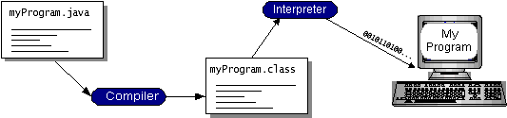

You can think of Java byte codes as the machine code instructions for the Java Virtual Machine (Java VM). Every Java interpreter, whether it’s a development tool or a Web browser that can run applets, is an implementation of the Java VM. Java byte codes help make “write once, run anywhere” possible. You can compile your program into byte codes on any platform that has a Java compiler. The byte codes can then be run on any implementation of the Java VM. That means that as long as a computer has a Java VM, the same program written in the Java programming language can run on Windows 2000, a Solaris workstation, or on an iMac.

**Networking**

TCP/IP stack

The TCP/IP stack is shorter than the OSI one:

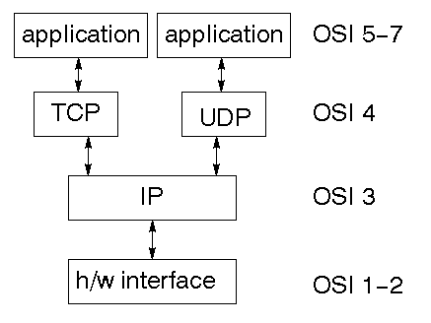

### TCP is a connection-oriented protocol; UDP (User Datagram Protocol) is a connectionless protocol.

**IP datagram’s**

The IP layer provides a connectionless and unreliable delivery system. It considers each datagram independently of the others. Any association between datagram must be supplied by the higher layers. The IP layer supplies a checksum that includes its own header. The header includes the source and destination addresses. The IP layer handles routing through an Internet. It is also responsible for breaking up large datagram into smaller ones for transmission and reassembling them at the other end.

**UDP**

UDP is also connectionless and unreliable. What it adds to IP is a checksum for the contents of the datagram and port numbers. These are used to give a client/server model - see later.

**TCP**

TCP supplies logic to give a reliable connection-oriented protocol above IP. It provides a virtual circuit that two processes can use to communicate.

**Internet addresses**

In order to use a service, you must be able to find it. The Internet uses an address scheme for machines so that they can be located. The address is a 32 bit integer which gives the IP address. This encodes a network ID and more addressing. The network ID falls into various classes according to the size of the network address.

**Network address**

Class A uses 8 bits for the network address with 24 bits left over for other addressing. Class B uses 16 bit network addressing. Class C uses 24 bit network addressing and class D uses all 32.

**Subnet address**

Internally, the UNIX network is divided into sub networks. Building 11 is currently on one sub network and uses 10-bit addressing, allowing 1024 different hosts.

**Host address**

8 bits are finally used for host addresses within our subnet. This places a limit of 256 machines that can be on the subnet.

**Total address**

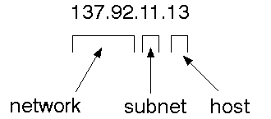

The 32 bit address is usually written as 4 integers separated by dots.

**Port addresses**

A service exists on a host, and is identified by its port. This is a 16 bit number. To send a message to a server, you send it to the port for that service of the host that it is running on. This is not location transparency! Certain of these ports are "well known".

**Sockets**

A socket is a data structure maintained by the system to handle network connections. A socket is created using the call socket. It returns an integer that is like a file descriptor. In fact, under Windows, this handle can be used with Read File and Write File functions.

#include <sys/types.h>

#include <sys/socket.h>

int socket(int family, int type, int protocol);

Here "family" will be AF_INET for IP communications, protocol will be zero, and type will depend on whether TCP or UDP is used. Two processes wishing to communicate over a network create a socket each. These are similar to two ends of a pipe - but the actual pipe does not yet exist.

**ODBC**

Microsoft Open Database Connectivity (ODBC) is a standard programming interface for application developers and database systems providers. Before ODBC became a de facto standard for Windows programs to interface with database systems, programmers had to use proprietary languages for each database they wanted to connect to. Now, ODBC has made the choice of the database system almost irrelevant from a coding perspective, which is as it should be. Application developers have much more important things to worry about than the syntax that is needed to port their program from one database to another when business needs suddenly change.

Through the ODBC Administrator in Control Panel, you can specify the particular database that is associated with a data source that an ODBC application program is written to use. Think of an ODBC data source as a door with a name on it. Each door will lead you to a particular database. For example, the data source named Sales Figures might be a SQL Server database, whereas the Accounts Payable data source could refer to an Access database. The physical database referred to by a data source can reside anywhere on the LAN.

The ODBC system files are not installed on your system by Windows 95. Rather, they are installed when you setup a separate database application, such as SQL Server Client or Visual Basic 4.0. When the ODBC icon is installed in Control Panel, it uses a file called ODBCINST.DLL. It is also possible to administer your ODBC data sources through a stand-alone program called ODBCADM.EXE. There is a 16-bit and a 32-bit version of this program and each maintains a separate list of ODBC data sources.

**JDBC**

In an effort to set an independent database standard API for Java; Sun Microsystems developed Java Database Connectivity, or JDBC. JDBC offers a generic SQL database access mechanism that provides a consistent interface to a variety of RDBMSs. This consistent interface is achieved through the use of “plug-in” database connectivity modules, or drivers. If a database vendor wishes to have JDBC support, he or she must provide the driver for each platform that the database and Java run on.

To gain a wider acceptance of JDBC, Sun based JDBC’s framework on ODBC. As you discovered earlier in this chapter, ODBC has widespread support on a variety of platforms. Basing JDBC on ODBC will allow vendors to bring JDBC drivers to market much faster than developing a completely new connectivity solution.

JDBC was announced in March of 1996. It was released for a 90 day public review that ended June 8, 1996. Because of user input, the final JDBC v1.0 specification was released soon after.

The remainder of this section will cover enough information about JDBC for you to know what it is about and how to use it effectively. This is by no means a complete overview of JDBC. That would fill an entire book.

**CHAPTER 3**

**PROJECT ARCHITECTURE**

**3.1 PROCESS MODEL USED WITH JUSTIFICATION**

**SDLC (Umbrella Model):**

**Umbrella Activity**

**Umbrella Activity**

**Umbrella Activity**

1. Feasibility Study
2. TEAM FORMATION
3. Project Specification PREPARATION

Business Requirement Documentation

ANALYSIS & DESIGN

CODE

UNIT TEST

DOCUMENT CONTROL

ASSESSMENT

TRAINING

INTEGRATION & SYSTEM TESTING

DELIVERY/INSTALLATION

ACCEPTANCE TEST

Requirements Gathering

SDLC is nothing but Software Development Life Cycle. It is a standard which is used by software industry to develop good software.

**Stages in SDLC:**

* Requirement Gathering
* Analysis
* Designing
* Coding
* Testing
* Maintenance

**Requirements Gathering** **stage:**

The requirements gathering process takes as its input the goals identified in the high-level requirements section of the project plan. Each goal will be refined into a set of one or more requirements. These requirements define the major functions of the intended application, define

operational data areas and reference data areas, and define the initial data entities. Major functions include critical processes to be managed, as well as mission critical inputs, outputs and reports. A user class hierarchy is developed and associated with these major functions, data areas, and data entities. Each of these definitions is termed a Requirement. Requirements are identified by unique requirement identifiers and, at minimum, contain a requirement title and

textual description.

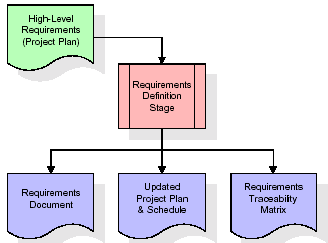

These requirements are fully described in the primary deliverables for this stage: the Requirements Document and the Requirements Traceability Matrix (RTM). The requirements document contains complete descriptions of each requirement, including diagrams and references to external documents as necessary. Note that detailed listings of database tables and fields are *not* included in the requirements document.

The title of each requirement is also placed into the first version of the RTM, along with the title of each goal from the project plan. The purpose of the RTM is to show that the product components developed during each stage of the software development lifecycle are formally connected to the components developed in prior stages.

In the requirements stage, the RTM consists of a list of high-level requirements, or goals, by title, with a listing of associated requirements for each goal, listed by requirement title. In this hierarchical listing, the RTM shows that each requirement developed during this stage is formally linked to a specific product goal. In this format, each requirement can be traced to a specific product goal, hence the term *requirements traceability*.

The outputs of the requirements definition stage include the requirements document, the RTM, and an updated project plan.

* Feasibility study is all about identification of problems in a project.
* No. of staff required to handle a project is represented as Team Formation, in this case only modules are individual tasks will be assigned to employees who are working for that project.
* Project Specifications are all about representing of various possible inputs submitting to the server and corresponding outputs along with reports maintained by administrator

**Analysis Stage:**

The planning stage establishes a bird's eye view of the intended software product, and uses this to establish the basic project structure, evaluate feasibility and risks associated with the project, and describe appropriate management and technical approaches.

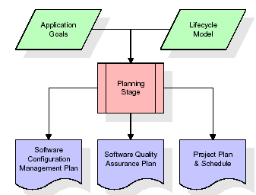

The most critical section of the project plan is a listing of high-level product requirements, also referred to as goals. All of the software product requirements to be developed during the requirements definition stage flow from one or more of these goals. The minimum information for each goal consists of a title and textual description, although additional information and references to external documents may be included. The outputs of the project planning stage are the configuration management plan, the quality assurance plan, and the project plan and schedule, with a detailed listing of scheduled activities for the upcoming Requirements stage, and high level estimates of effort for the out stages.

**Designing Stage:**

The design stage takes as its initial input the requirements identified in the approved requirements document. For each requirement, a set of one or more design elements will be produced as a result of interviews, workshops, and/or prototype efforts. Design elements describe the desired software features in detail, and generally include functional hierarchy diagrams, screen layout diagrams, tables of business rules, business process diagrams, pseudo code, and a complete entity-relationship diagram with a full data dictionary. These design elements are intended to describe the software in sufficient detail that skilled programmers may develop the software with minimal additional input.

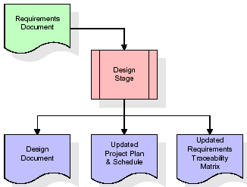

When the design document is finalized and accepted, the RTM is updated to show that each design element is formally associated with a specific requirement. The outputs of the design stage are the design document, an updated RTM, and an updated project plan.

**Development (Coding) Stage:**

The development stage takes as its primary input the design elements described in the approved design document. For each design element, a set of one or more software artifacts will be produced. Software artifacts include but are not limited to menus, dialogs, data management forms, data reporting formats, and specialized procedures and functions. Appropriate test cases will be developed for each set of functionally related software artifacts, and an online help system will be developed to guide users in their interactions with the software.

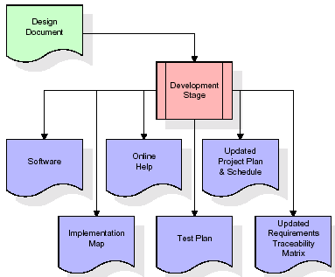

The RTM will be updated to show that each developed artifact is linked to a specific design element, and that each developed artifact has one or more corresponding test case items. At this point, the RTM is in its final configuration. The outputs of the development stage include a fully functional set of software that satisfies the requirements and design elements previously documented, an online help system that describes the operation of the software, an implementation map that identifies the primary code entry points for all major system functions, a test plan that describes the test cases to be used to validate the correctness and completeness of the software, an updated RTM, and an updated project plan.

**Integration & Test Stage:**

During the integration and test stage, the software artifacts, online help, and test data are migrated from the development environment to a separate test environment. At this point, all test cases are run to verify the correctness and completeness of the software. Successful execution of the test suite confirms a robust and complete migration capability. During this stage, reference data is finalized for production use and production users are identified and linked to their appropriate roles. The final reference data (or links to reference data source files) and production user list are compiled into the Production Initiation Plan.

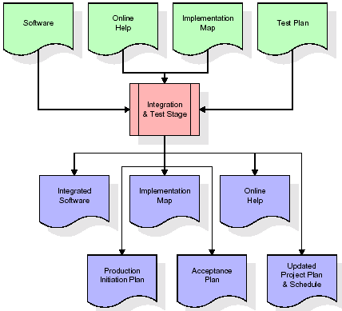

The outputs of the integration and test stage include an integrated set of software, an online help system, an implementation map, a production initiation plan that describes reference data and production users, an acceptance plan which contains the final suite of test cases, and an updated project plan.

* **Installation & Acceptance Test:**

During the installation and acceptance stage, the software artifacts, online help, and initial production data are loaded onto the production server. At this point, all test cases are run to verify the correctness and completeness of the software. Successful execution of the test suite is a prerequisite to acceptance of the software by the customer.

After customer personnel have verified that the initial production data load is correct and the test suite has been executed with satisfactory results, the customer formally accepts the delivery of the software.

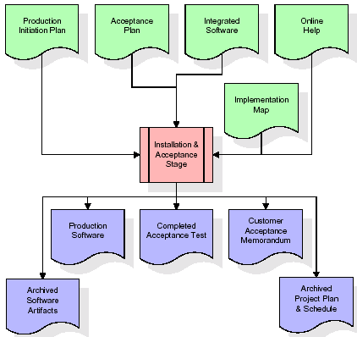

The primary outputs of the installation and acceptance stage include a production application, a completed acceptance test suite, and a memorandum of customer acceptance of the software. Finally, the PDR enters the last of the actual labor data into the project schedule and locks the project as a permanent project record. At this point the PDR "locks" the project by archiving all software items, the implementation map, the source code, and the documentation for future reference.

**Maintenance:**

Outer rectangle represents maintenance of a project, Maintenance team will start with requirement study, understanding of documentation later employees will be assigned work and they will under go training on that particular assigned category.

For this life cycle there is no end, it will be continued so on like an umbrella (no ending point to umbrella sticks).

**CHAPTER 4**

**ARCHITECTURE BLOCKS DETAIL WORKING**

**Architecture flow:**

Below architecture diagram represents mainly flow of requests from users to database through servers. In this scenario overall system is designed in three tires separately using three layers called presentation layer, business logic layer and data link layer. This project was developed using 3-tire architecture.

**SERVER**

**User**

**Data Base**

**Request**

**Response**

**URL Pattern:**

**Presentation Layer**

**SERVLETS AT THE SERVER SIDE**

**URL Request sent through the browser**

**Response sent from the servlet**

**DATABASE**

**Verifying or updating the database** **through a statement**

**Reply from the database according to the statement**

URL pattern represents how the requests are flowing through one layer to another layer and how the responses are getting by other layers to presentation layer through server in architecture diagram.

**CHAPTER 5**

**MODULES**

**5.1 MODULE DESCRIPTION**

**1.Manager**

Here manager is a module here manage can login directly with specified username and password, after successful login he can perform some operations such as add products details , view all products details or reviews, add all sales details and view all sales details and logout

**CONCLUSION**

he project entitled ' Online Grocery Management System ' is very convenient for the

Computer Companies. This system is very convenient for customer or users to buy online

computer products. It can be observe that the information can be obtained easily and accurately.

The online grocery shopping Software is made more user friendly to the users, so that anyone

can run the software. Then this software provide permission to enter to the system via the login

password credentials to the user who use this system . This project manages all the details about

Computer Products.

The project entitled ' Online Grocery Management System ' is very convenient for the Computer Companies. This system is very convenient for customer or users to buy online computer products. It can be observe that the information can be obtained easily and accurately. The online grocery shopping Software is made more user friendly to the users, so that anyone can run the software. Then this software provide permission to enter to the system via the login password credentials to the user who use this system. This project manages all the details about Computer Products.

**FUTURE SCOPE**

The project entitled ' Online Grocery Management System ' is very convenient for the

Computer Companies. This system is very convenient for customer or users to buy online

computer products. It can be observe that the information can be obtained easily and accurately.

The online grocery shopping Software is made more user friendly to the users, so that anyone

can run the software. Then this software provide permission to enter to the system via the login

password credentials to the user who use this system . This project manages all the details about

Computer Products.

The project entitled ' Online Grocery Management System ' is very convenient for the

Computer Companies. This system is very convenient for customer or users to buy online

computer products. It can be observe that the information can be obtained easily and accurately.

The online grocery shopping Software is made more user friendly to the users, so that anyone

can run the software. Then this software provide permission to enter to the system via the login

password credentials to the user who use this system . This project manages all the details about

Computer Products.

The project entitled ' Online Grocery Management System ' is very convenient for the

Computer Companies. This system is very convenient for customer or users to buy online

computer products. It can be observe that the information can be obtained easily and accurately.

The online grocery shopping Software is made more user friendly to the users, so that anyone

can run the software. Then this software provide permission to enter to the system via the login

password credentials to the user who use this system . This project manages all the details about

Computer Products.

The project entitled ' Online Grocery Management System ' is very convenient for the

Computer Companies. This system is very convenient for customer or users to buy online

computer products. It can be observe that the information can be obtained easily and accurately.

The online grocery shopping Software is made more user friendly to the users, so that anyone

can run the software. Then this software provide permission to enter to the system via the login

password credentials to the user who use this system . This project manages all the details about

Computer Products.

The project entitled ' Online Grocery Management System ' is very convenient for the

Computer Companies. This system is very convenient for customer or users to buy online

computer products. It can be observe that the information can be obtained easily and accurately.

The online grocery shopping Software is made more user friendly to the users, so that anyone

can run the software. Then this software provide permission to enter to the system via the login

password credentials to the user who use this system . This project manages all the details about

Computer Products.

The project entitled ' Online Grocery Management System ' is very convenient for the

Computer Companies. This system is very convenient for customer or users to buy online

computer products. It can be observe that the information can be obtained easily and accurately.

The online grocery shopping Software is made more user friendly to the users, so that anyone

can run the software. Then this software provide permission to enter to the system via the login

password credentials to the user who use this system . This project manages all the details about

Computer Products.

The project entitled ' Online Grocery Management System ' is very convenient for the

Computer Companies. This system is very convenient for customer or users to buy online

computer products. It can be observe that the information can be obtained easily and accurately.

The online grocery shopping Software is made more user friendly to the users, so that anyone

can run the software. Then this software provide permission to enter to the system via the login

password credentials to the user who use this system . This project manages all the details about

Computer Products.

The project entitled ' Online Grocery Management System ' is very convenient for the

Computer Companies. This system is very convenient for customer or users to buy online

computer products. It can be observe that the information can be obtained easily and accurately.

The online grocery shopping Software is made more user friendly to the users, so that anyone

can run the software. Then this software provide permission to enter to the system via the login

password credentials to the user who use this system . This project manages all the details about

Computer Products.

The project entitled ' Online Grocery Management System ' is very convenient for the

Computer Companies. This system is very convenient for customer or users to buy online

computer products. It can be observe that the information can be obtained easily and accurately.

The online grocery shopping Software is made more user friendly to the users, so that anyone

can run the software. Then this software provide permission to enter to the system via the login

password credentials to the user who use this system . This project manages all the details about

Computer Products.

The project entitled ' Online Grocery Management System ' is very convenient for the

Computer Companies. This system is very convenient for customer or users to buy online

computer products. It can be observe that the information can be obtained easily and accurately.

The online grocery shopping Software is made more user friendly to the users, so that anyone

can run the software. Then this software provide permission to enter to the system via the login

password credentials to the user who use this system . This project manages all the details about

Computer Products.

The project entitled ' Online Grocery Management System ' is very convenient for the

Computer Companies. This system is very convenient for customer or users to buy online

computer products. It can be observe that the information can be obtained easily and accurately.

The online grocery shopping Software is made more user friendly to the users, so that anyone

can run the software. Then this software provide permission to enter to the system via the login

password credentials to the user who use this system . This project manages all the details about

Computer Products.

The project entitled ' Online Grocery Management System ' is very convenient for the

Computer Companies. This system is very convenient for customer or users to buy online

computer products. It can be observe that the information can be obtained easily and accurately.

The online grocery shopping Software is made more user friendly to the users, so that anyone

can run the software. Then this software provide permission to enter to the system via the login

password credentials to the user who use this system . This project manages all the details about

Computer Products.

The project entitled ' Online Grocery Management System ' is very convenient for the

Computer Companies. This system is very convenient for customer or users to buy online

The project entitled ' Online Grocery Management System ' is very convenient for the

Computer Companies. This system is very convenient for customer or users to buy online

The project entitled ' Online Grocery Management System ' is very convenient for the

Computer Companies. This system is very convenient for customer or users to buy online

The project entitled ' Online Grocery Management System ' is very convenient for the

Computer Companies. This system is very convenient for customer or users to buy online

In Future users can buy there identical products using mobile phones. This

organization is very beneficial for both users and companies. This product has great

future scope. Online grocery project established using web based technology and for

Windows too future versions of environments. This project also delivers security by using

a security credentials like user id as well as password, so that any illegal users cannot

practice your account. The only Lawful person that will consume proper admittance

authority can use the online grocery shopping softwar

In Future users can buy there identical products using mobile phones. This

organization is very beneficial for both users and companies. This product has great

future scope. Online grocery project established using web based technology and for

Windows too future versions of environments. This project also delivers security by using

a security credentials like user id as well as password, so that any illegal users cannot

practice your account. The only Lawful person that will consume proper admittance

authority can use the online grocery shopping softwar

In Future users can buy there identical products using mobile phones. This organization is very beneficial for both users and companies. This product has great future scope. Online grocery project established using web based technology and for Windows too future versions of environments. This project also delivers security by using a security credentials like user id as well as password, so that any illegal users cannot practice your account. The only Lawful person that will consume proper admittance authority can use the online grocery shopping software.

**REFERENCES**

References for the Project Development Were Taken From the following Books and Web Sites.

**JAVA Technologies**

JAVA Complete Reference

Java Script Programming by Yehuda Shiran

Mastering JAVA Security

JAVA2 Networking by Pistoria

JAVA Security by Scotl oaks

Head First EJB Sierra Bates

J2EE Professional by Shadab siddiqui

JAVA server pages by Larne Pekowsley

JAVA Server pages by Nick Todd

**HTML**

HTML Black Book by Holzner

**JDBC**

Java Database Programming with JDBC by Patel moss.

Software Engineering by Roger Pressman

**CODE**

**https://github.com/Jakkala-Manisha/Grocery-Management-System-Project.git**